**Experiment No. 2.3**

**Student Name: Jesu Yuvraj UID: 22MCI10074**

**Branch: MCA Section/Group: MAM-1/ Grp B**

**Semester: I Date of Performance: 1st Dec 22**

**Subject Name: ADBMS LAB Subject Code: 22CAP-637**

1. **Aim/Overview of the practical:**

Generate the following two result sets:

1.Query an alphabetically ordered list of all names in OCCUPATIONS, immediately followed

by the first letter of each profession as a parenthetical (i.e.: enclosed in parentheses). For example: AnActorName(A), ADoctorName(D), AProfessorName(P), and ASingerName(S).

2.Query the number of ocurrences of each occupation in OCCUPATIONS. Sort the occurrences in ascending order, and output them in the following format:

There is a total of [occupation_count] [occupation]s.

where [occupation_count] is the number of occurrences of an occupation in OCCUPATIONS and [occupation] is the lowercase occupation name. If more than one Occupation has the same [occupation_count], they should be ordered alphabetically.

**Note:** There will be at least two entries in the table for each type of occupation.

1. **Code for experiment/practical:**

create table Info(Name varchar(20), Occupation varchar(20));  
insert into Info values("Rishav", "Student");  
insert into Info values("Lucky", "Professor");  
insert into Info values("Jesu", "Actor");  
insert into Info values("Shika", "Model");  
insert into Info values("Amar", "Student");  
insert into Info values("Rishant", "Actor");  
insert into Info values("Sushil", "Professor");  
insert into Info values("Aneesh", "Student");  
insert into Info values("Atharav", "Singer");  
  
select Info.Name, SUBSTR(Occupation, 1, 1) As Occupation   
from Info  
Order by Name asc;

SELECT "There are total of" Name,   
COUNT(*) AS `Count`, Occupation  
FROM Info  
GROUP BY Occupation

1. **Output:**

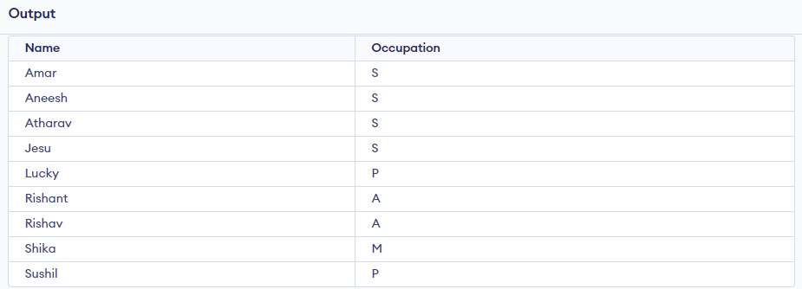

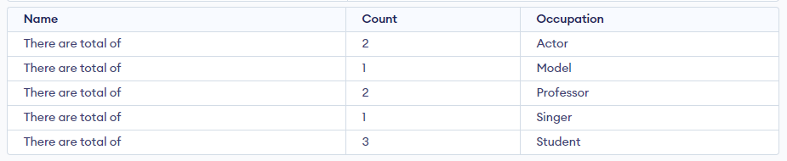

**************************************** **THE END** ***********************************************